**REGISTRATION FORTHCOMING!! Email or call Kamela Johnson, Network of Neighbors Response Planner, 267-233-4871,** [**kamela.johnson@phila.gov**](mailto:kamela.johnson@phila.gov) **for more information and registration link**

**WHEN**

Wednesday, March 24, 8:30am - 5:00pm

Thursday, March 25, 8:30am - 5:00pm

Friday, March 26, 8:30am - 1:00pm

**WHERE**

801 Market St, 11th floor, room 1154 A

Philadelphia PA 19107

**Trainer: Dr. Robert Macy**

**International Trauma Center**

This 2.5-day training will equip attendees to support individuals and communities after incidents of violence and trauma. The two trainings included are:

* Psychological First Aid—an evidence-informed approach for assisting children, adolescents, adults, and families in the aftermath of disaster and terrorism
* Post-Traumatic Stress Management—a community-based acute trauma response intervention to be utilized in the wake of community violence

Trauma Responders who attend the full training will be equipped to offer group supports, which

* Foster the natural, human tendency to group together, seeking solace and safety after traumatic incidents
* Reduce acute traumatic stress common among survivors
* Refer to and access community based resources as needed

**1.3 IACET CEUs are available after full training attendance.**

Questions? Email Ysaye.Zamore@phila.gov.

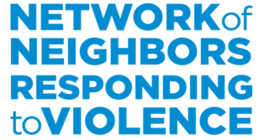Questions? Check out our website [www.DBHIDS.org/NetworkOfNeighbors](http://www.DBHIDS.org/NetworkOfNeighbors) and follow us on twitter @PhilaNeighbNet