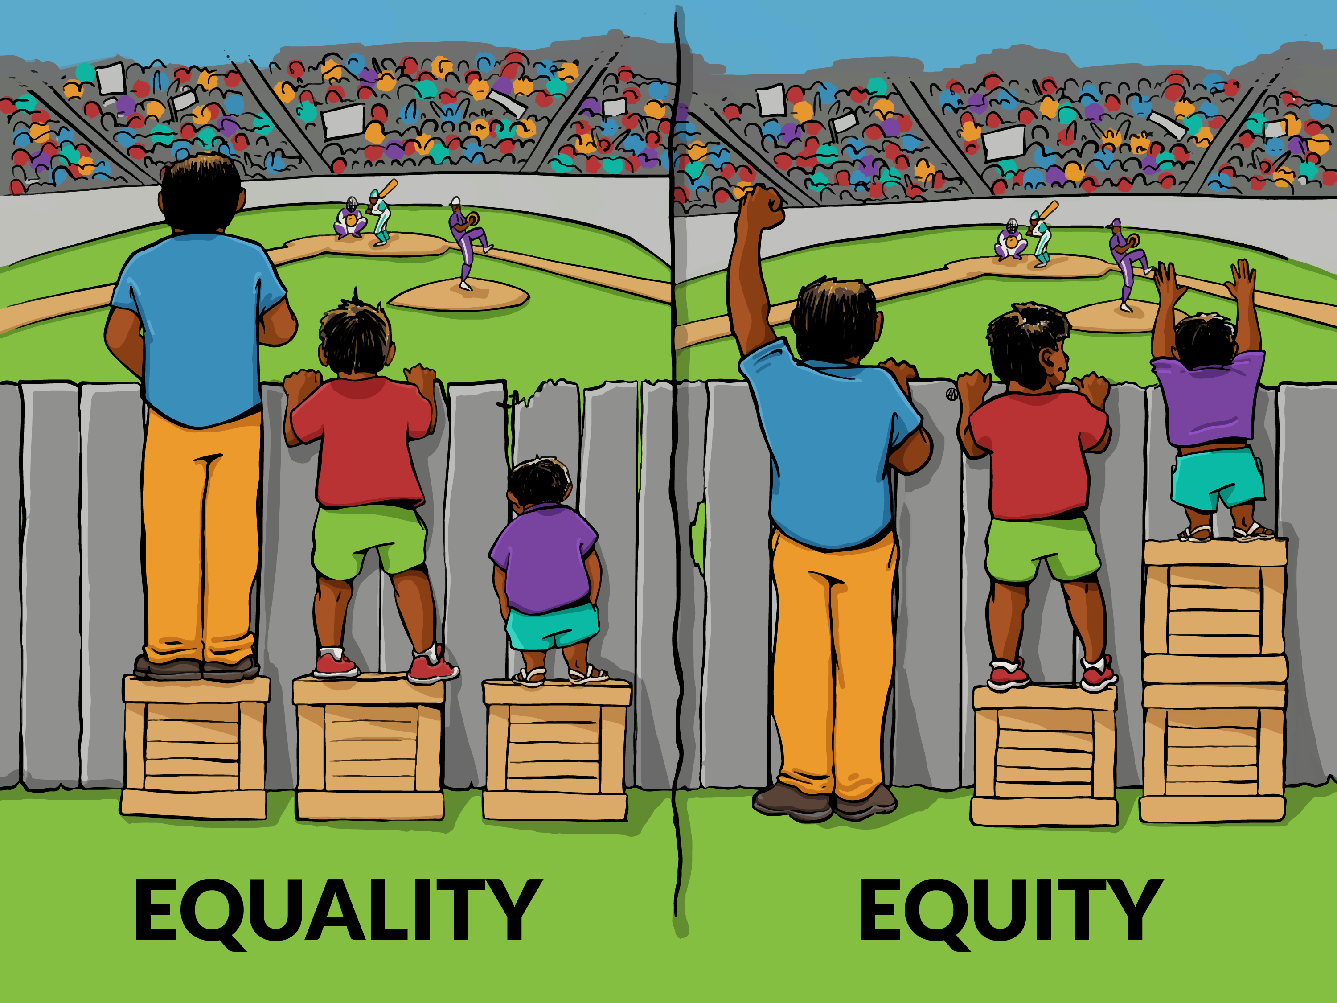
Spring 2017
Internship in Sociology - SOC 363
Tuesday/Thursday, 2:10 – 3:50PM
Easton Hall 346
Dr. Doreen Loury
Office: Easton Hall 334
Phone: (Office) 215-572-4087, (Cell) 267-228-8423
Email: loury@arcadia.edu
Office Hours: Wed (10-3) & Fri (10-2)

Internship in Sociology
“The purpose of a change agent is to empower people.”
“Leaders become great, not because of their power but because of their ability to empower others.”

COURSE OVERVIEW
The Internship course is designed to give junior and senior students who are majoring/minoring in Sociology/Criminology experience in their chosen career field and is an extension and application of prerequisite academic skills. Internships involve hands-on experiential learning in a variety of community based, non-profit or governmental organizations and students are required to observe and participate in a job-related capacity under supervision. The purpose of the internship is to develop a learning experience for both the student and the organization. The course provides students with an opportunity to gain first-hand experience in a professional setting. This supervised learning experience permits students to work directly with both organizational personnel and clientele. Students will learn to link academic knowledge to their placements, understand the relationship between theory and applied practice on an interpersonal level and continue to foster personal and professional growth.

In today’s world, it is impossible to escape the topic of leadership. From government and non-profit organizations to sports teams and social groups, leadership is attributed to the biggest success and the grandest failures. But what is leadership, who is a leader and how can your participation in an internship help you understand your own leadership capabilities?

The course will provide conceptual information and experiential components aimed at enhancing basic communication skills that underlie social interactions, professional interviewing and the structures and techniques that can be applied across a variety of professional settings. Additionally, students will develop the awareness of the impact that personal attitudes, beliefs, feelings and behaviors impact their career decision. Throughout the course issues related to human diversity, social justice and equality will be addressed and specific cross-cultural skills will be practiced. This course will also explore the concept of leadership grounded with theory, but with an emphasis on the personal meaning and definition of leadership that best fits your leadership identity.

Using class discussions, small group activities, role-plays, journaling, assigned readings, peer discussion of internship experiences and self-assessment activities students will have ample opportunity to actively work on their strengths and challenges as they integrate and apply their knowledge of social processes and social welfare, social justice and the foundations of leadership.

Textbook:
Komives, S.R., Wagner, W., & Associates – Leadership for a Better World: Understanding the Social Change Model of Leadership San Francisco: Jossey-Bass (2nd Edition):

STUDENT OUTCOMES
Upon completion of this course, students will:
- Understand the organizational structure and functions of the placement agency
- Explore leadership myths and realities
- Begin to value leadership as a process, not just a position
- Appreciate the relationship between academic and experiential knowledge
- Apply critical analysis skills to “real world” settings
- Describe experiences and personal growth during the semester
- Articulate the mission of the host organization
- Observe and reflect on how the mission is carried out by the leadership within the organization
- Identify the skills and attributes needed for the potential career
- Clarify education and education goals
- Explore possible career choices
- Gain useful criminal justice & human service experience, and improve employment potential upon graduation
- Experience the “real world” of criminal justice and human service
- Establish a network of contacts within the field of criminal justice and human service
- Develop job-relevant skills through the tasks they complete at the agency site (i.e., communication, report writing, interviewing, shadowing, etc.)
- Apply generic and evidence based practice principles in the development of relationships with various client systems, being sensitive to issues of ethnicity, race, gender, age, cultural differences, sexual orientation, etc.
- Learn the importance and of selecting and implementing evidence-based interventions
- Learning how to utilize various theoretical perspectives in the implementation of the roles of brokering, advocacy, counseling, outreach and clinical treatment
- Develop the ability to communicate effectively with agency staff and to appropriately handle inter-agency initiatives and challenges
- Enhance their ability to analyze and advocate for social policies and practices that support a desirable quality of life for individuals, families and communities

COURSE REQUIREMENTS
Internship
Each student will be required to complete 10 hours per week at an agency during the semester. It is recommended that 100-120 hours for the internship. Your participation in the AU LEAD Workshops will count as (10) of those hours. The student will coordinate with the agency selected and the Faculty Liaison, Dr. Loury, as to what the student will accomplish during the course of the internship.

You are expected to fulfill intern responsibilities as delineated by your site and your internship supervisor(s). Good supervision is a two-way process, so communicate effectively and fully with your supervisor and with us on a regular basis. Within the first half-hour of the seminar there will be time set aside for us to discuss your site, clients, concerns, etc.

We will be visiting your internship placements at least once during the semester. Specific time, etc. will be arranged after your work gets underway.
ASSIGNMENTS

Assignment #1 – Story of Self 5-7 page,). A story of self tells why we have been called to serve. It expresses the values or experiences that call each person to take leadership on a given issue. The key focus is on choice points: moments in our lives when values are formed because of a need to choose in the face of great uncertainty. When did you first care about being heard, or learn that you were concerned about the issue on which you want to take action? Why? When did you feel you had to do something about it? Why did you feel you could? What were the circumstances? What specific choice did you make? Due Date February 16th.
http://billmoyers.com/content/how-to-tell-your-story-of-self/

Assignment #2 - Site Portfolio
Purchase a three ring- binder with seven dividers and at least two pockets for pamphlets and business cards. The Table of contents will be the first page. 1st divider will include your reflective journal, 2nd will be an organizational profile (handout) of your internship site with brochures, pamphlets, agency information sheet, confidentiality statement, organizational chart, business cards, etc., 3rd will be a “proposed” site project (handout) linking your placement to academic concepts in sociology, criminal justice, etc., 4th will be your grant, 6th will be your resource list, and 7th will be your personal summary account of your experience at the agency. You will provide appendices as well. (Due April 25th)

Assignment #3 - Internship Reflective Journal:
You are to keep an internship journal in which you critically reflect upon and analyze your internship experience. The journal is to be a self-conscious effort at thinking about what you are learning. Notes, reflections, insights, connections and critiques from work experiences, readings and other relevant experiences are to be recorded in your journal. Journal entries should reflect a serious effort to synthesize theory and practice. You are expected to write in the journal each time you are at your site. Each journal entry should be at least ¾ of a page in length. Journals may be typed or hand-written. Not sure what to write about or how to begin the process? Review the handout, “Some Answers to the Nagging Question: “What Should I Write In My Journal?” Journals are due on the following dates: 2/14, 2/23, 3/9, 3/30, 4/13, 5/9.

Assignment #4 - Internship Personal Summary (3-5 pages)
You will provide a 3-5 page paper outlining the Internship experience. You will address the following items in the Personal Summary: name of agency, name of supervisor, primary responsibilities you were given to perform during the Internship, challenges and problems you experienced, problem-solving techniques you employed to resolve the challenge/problem, experiences in which you gained valuable skills and/or knowledge during the Internship, recommendations for future internships at the agency. This is your change to influence future program and course content for the department, take advantage of it. You will not be penalized in any way for your opinions. (April 25th with site portfolio)

Assignment # 5 - Personal/Professional Skills Portfolio
Purchase a large three-ring binder with dividers. Table of contents will be the first page.
1st - Introduction (Story of Self Paper), Updated Resume, your “ME” information file, FOCUS Analysis, Skills Inventory, Social Change Activities/Assignments).
2nd - Description of Learning Areas
3^{rd –} AU LEAD Reflections
4th – Social Change & Leadership Action Plan
5th - Appendices Section (Copies – Practicum Learning Contract, Supervisor Evaluations, Self-Evaluation, interview rubric and reflection, FOCUS and PAI printouts and reflection, and other relevant material). We will be adding to this list during the course of the semester. (Due May 9th)

Assignment #6 – Social Change & Leadership Action Plan (Mid-Term)
Write a 5-7 page paper reflecting on what you learned during the semester about leadership, with a focus on social change. Handout will be provided. (Due March 7)

Assignment #7 – Organizational Profile – Due 3/21 – See Handout
Proposed Site Project – Due – 4/11 – See Handout

Assignment #8 – Site Grant Application (Final Paper)
Your final paper will be the development of a grant for your internship site. Handout will be provided (Due May 9th)

