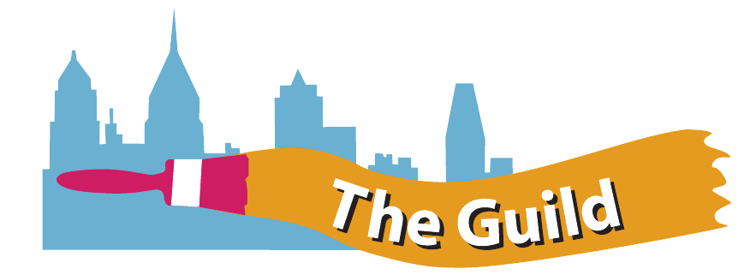
Mural Arts’ Philadelphia Restorative Justice/Guild Program

About Restorative Justice: Restorative Justice incorporates the victim, offender and community in all programs and projects. The programs provide participants involved in the criminal justice system opportunities to engage in pro-social activities and make amends for harm caused to their communities by creating murals and acquiring new job-readiness skills. We do this through a number of programs, including the Guild program for reentry and young adults on probation and at Graterford Prison. We offer art instruction, and specialized classes in carpentry, mosaic and glass work, with involvement in mural projects throughout the City of Philadelphia. We have programs at SCI Graterford, the Philadelphia Department of Prisons and at the Thomas Eakins House for the Guild.
About the Guild: The Guild program started in December 2009 in partnership with the City of Philadelphia Youth Violence Reduction Partnership (YVRP) and the Philadelphia Prison System. The goal of the program is to decrease recidivism rates and develop networks and interventions that strengthen support for Guild members to obtain and keep employment. We have achieved a recidivism rate of 16%, significantly lower than Philadelphia’s 35% recidivism rate for those released to halfway houses and directly home (first year after release, which is the most vulnerable time for re-incarceration). It is worth noting that that the younger cohort that we work with has substantially higher three-year recidivism rates (78% age 21 decreasing to 37% for those over 50) than older Pennsylvanians exiting the justice system. We have worked on over 50 projects, including murals, community gardens and restorations.

